**60 Years of Daily Newspaper Circulation Trends**

<http://media-cmi.com/downloads/Sixty_Years_Daily_Newspaper_Circulation_Trends_050611.pdf>

In the 20th century, media were intermediaries, connecting content, consumers, and advertisers. That role was influenced by the limited number of media players – a function, at least in part, of capital costs in print and regulatory and “spectrum scarcity” considerations in broadcast. So the economic structure for many media was based on what might be called a “coincidence of oligopoly”.

“*For the first time in history, on a mass scale, the means of production and distribution for information and entertainment products are finding their way into the hands of the consumers “*

* “.Marshall McLuhan put it more starkly in 1964, in his book, *Understanding Media: The Extensions of Man*: The classified ads (and stock-market quotations) are the bedrock of the press. Should an alternative source of easy access to such diverse daily information be found, the press will fold.2 “

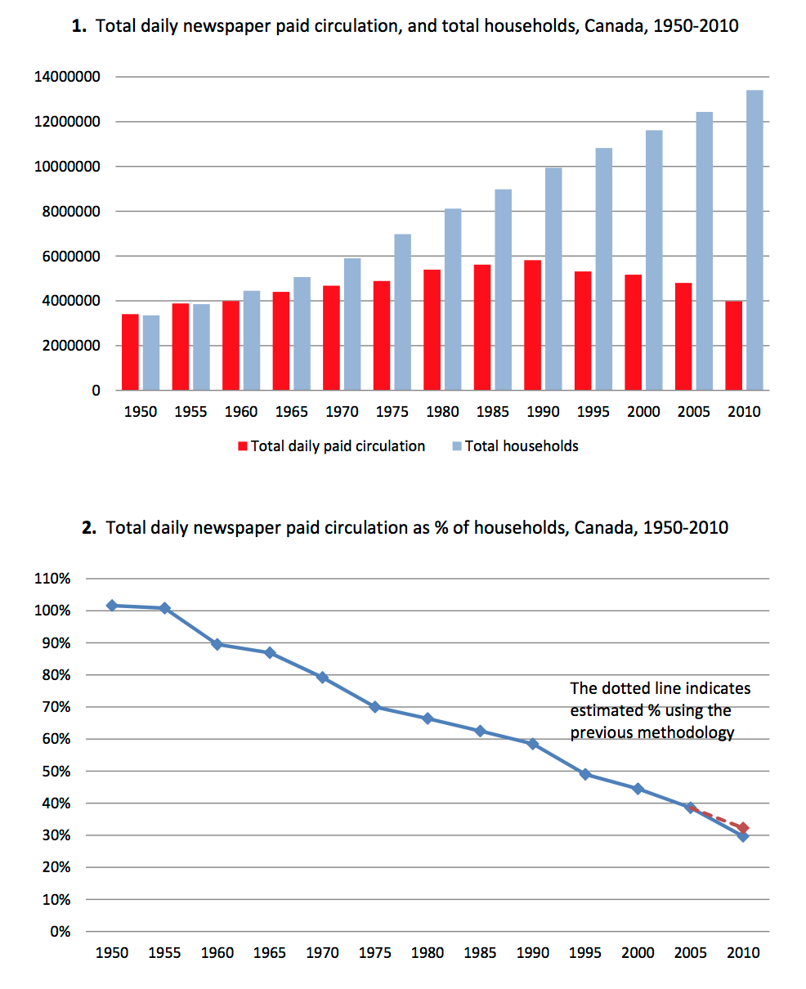In 1950, the average daily total paid circulation for U.S. daily newspapers was 53.8 million (equivalent to 123.6 per cent of households); the total paid circulation for U.S. Sunday newspapers was 46.6 million (equivalent to 107.0 per cent of households).

By 2010, the average daily total paid circulation for U.S. daily newspapers was about 43.4 million (equivalent to 36.7 per cent of households); the total paid circulation for U.S. Sunday newspapers was about 44.1 million (equivalent to 37.3 per cent of households).

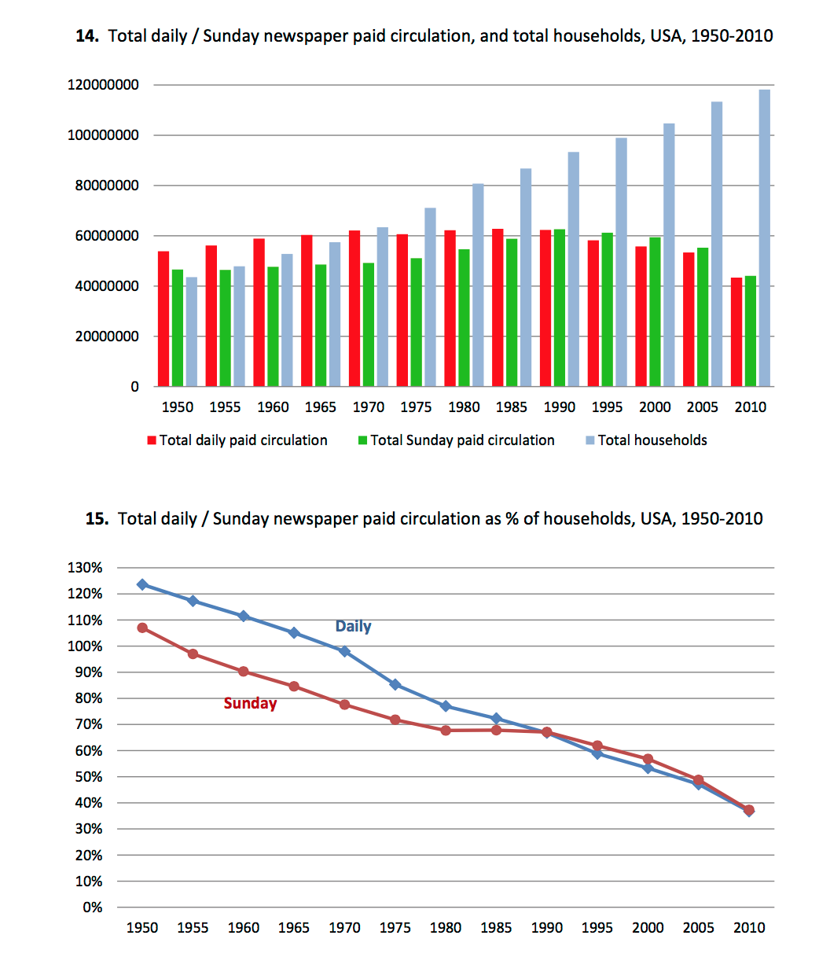

* In the United Kingdom, national newspaper circulation is specifically referred to in legislation dealing with ownership of television services. Both the U.K. *Broadcasting Act 1990* and the U.K. *Communications Act 2003* contain provisions that restrict the amount of a television service that a newspaper proprietor can own, if that newspaper proprietor has more than a 20 per cent share of the national newspaper market. And the market share is measured on the basis of circulation.

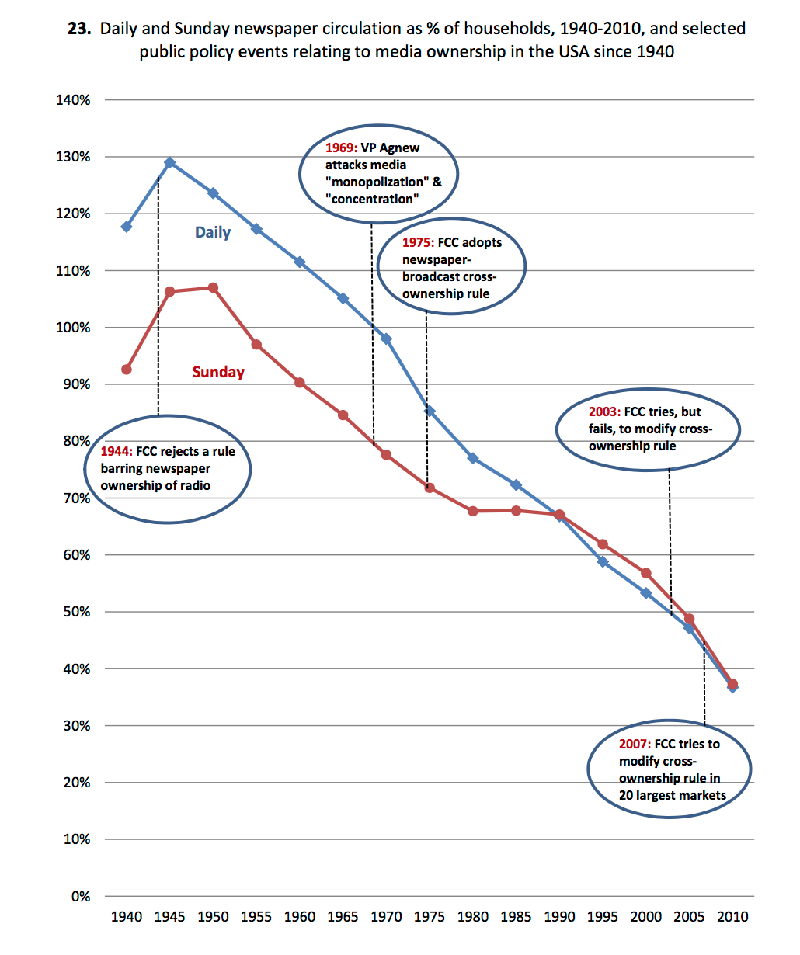

On November 5, 1940, President Franklin Delano Roosevelt was re-elected to an unprecedented third term in office with 55 per cent of the popular vote. During the campaign, the majority of daily newspapers had opposed his re-election and supported his Republican opponent. And a number of those newspapers owned radio stations.

On December 3, 1940, President Roosevelt sent an 18-word memorandum to FCC Chairman James Lawrence Fly, asking him to initiate a hearing into newspaper ownership of radio stations. (20)

Wanted to encourage diversification but: The Commission has concluded, in the light of the record in this proceeding and of the grave legal and policy questions involved, not to adopt any general rule with respect to newspaper ownership of radio stations (21)

* In the case of television, it was a question of shifting habits of how consumers spent their time. In the case of the Internet, it is that, and more – because the Internet enables reception of competing content from everywhere, and also enables the “unbundling” of the traditional newspaper package.
* The idealized notion of competing voices is a good thing. But it is precisely because of the number of alternative competing voices, and consumer acceptance of those voices, that daily newspaper circulations are declining. Indeed, if the trends of the past 10 years continue for the next 10 years, and if there is no plateau, then daily newspaper circulations could fall to a level equivalent to 20-25 per cent of households by 2020.